Advanced Engineering Mathematics, by Erwin Kreyszig 10th. Ed.

**Problem Set 3.2**

No. 1



Auxiliary equation: 





General sol.: 

No. 2



Auxiliary equation: 



(double root)

(double root)



General sol.: 

No. 3



Auxiliary equation:  

(Double root)





General sol.: 

No. 4

 

Auxiliary equation: 



 double root



General sol.: 

No. 5

 

Auxiliary equation:  





General sol.: 

No. 6



Auxiliary equation:  





General sol.: 

No. 7



Auxiliary equation 







General sol.: 

 



 

Since









From (1) we know C1 = 1.5, and from (2) B = 2.25

Particular sol.: 

No. 8



Auxiliary equation 







General sol.:  



 





 

Since

 

 

 

 

  

 





Particular sol.: 

No. 9



Auxiliary equation 







General sol.:  



 





  

Since

 

 

 

  

  

 





Particular sol.: 

No. 10



Auxiliary equation  











General sol.:  



 









 







Since

 

 

 

 

   + 

Fromis obtained.

andsubstituted into  

+



Particular sol.: 

No. 11



Auxiliary equation 







General sol.: 







The initial values,  are inserted into

, respectively.













From (5) and (6) we get 

Then from (1) A = -1 is obtained. Final B = 0

Particular sol.: 

No. 12



Auxiliary equation 







General sol.:  

 

 

 

 

The initial values,  are inserted into

, respectively.

 

 

 

 

 

 



From (6) and (7) we get  and then substituted into (2) and (3)

 

 

Then from (8) and (9)  are obtained. Finally from (1) 

Particular sol.: 

No. 13

Auxiliary equation 









General sol.:  

 

 

 

The initial values,  are inserted into, respectively.

 

 

 

 

 

 



Then from (1) 

Finally from (2) 

Particular sol.: 

No. 14

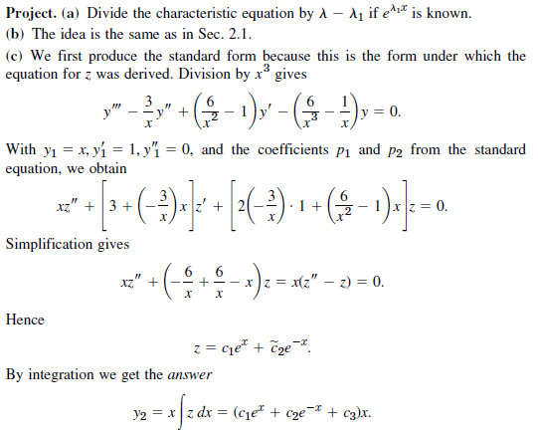

No. 15

